***Session 1: How to Solve Big Data***

***Assignment 1.1***

1. I have downloaded the oracle vm software installed it and imported the acadgild software.

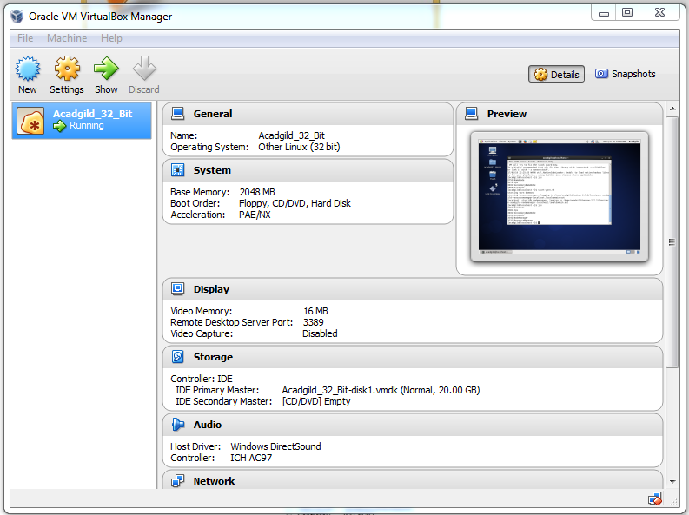

2.

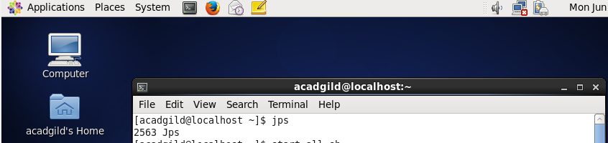

3.

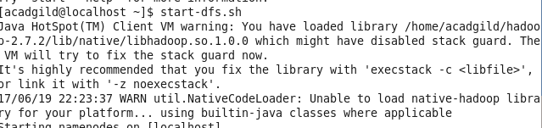

4. 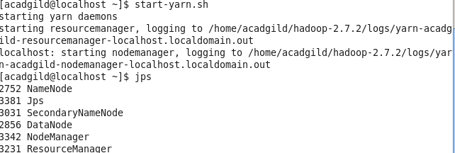

5. 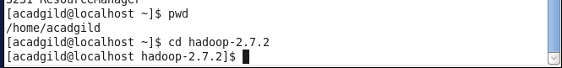

6. 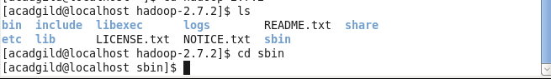

7.

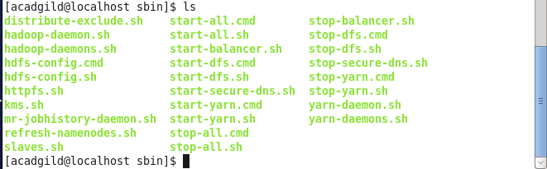

8. 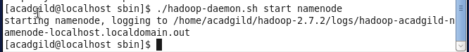

9.

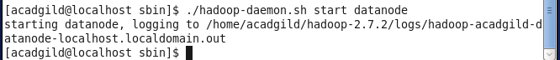

10.

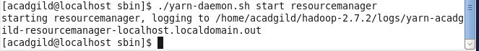

11.

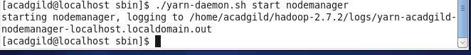

12.

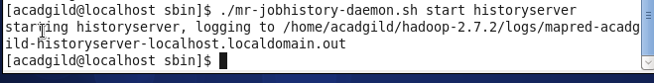

13.

